International Information Technologies University



**Web Technologies**

Report

Course Work

Qazaqstan Premier League

Done by: Myrzan Bekzat

Group: CSSE-1803K

Team: MBM

2020, Almaty

**CONTENT**

1. Content

2. Introduction

3. Main Part

4. Conclusion

5. References

**Introduction**

In this course work, we worked on our skills and techniques acquired over the past 6 weeks, and summarize by creating/building one fully working website/project. Our site is about Qazaqstan premier league. Simplification of work and digitization helps training institutions

**Main Part**





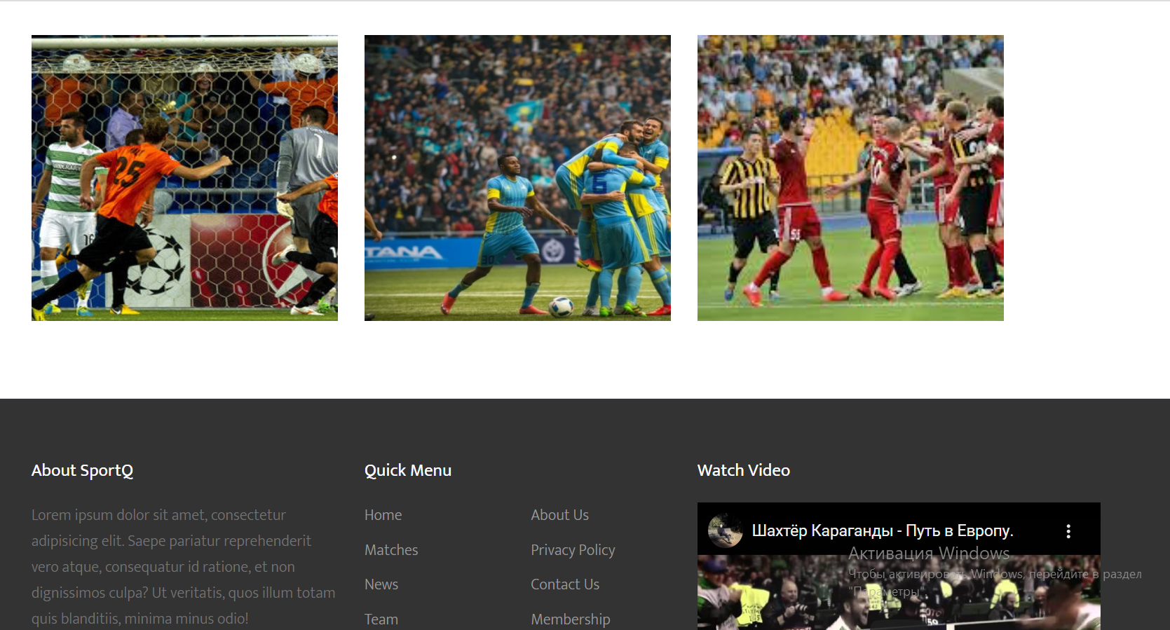

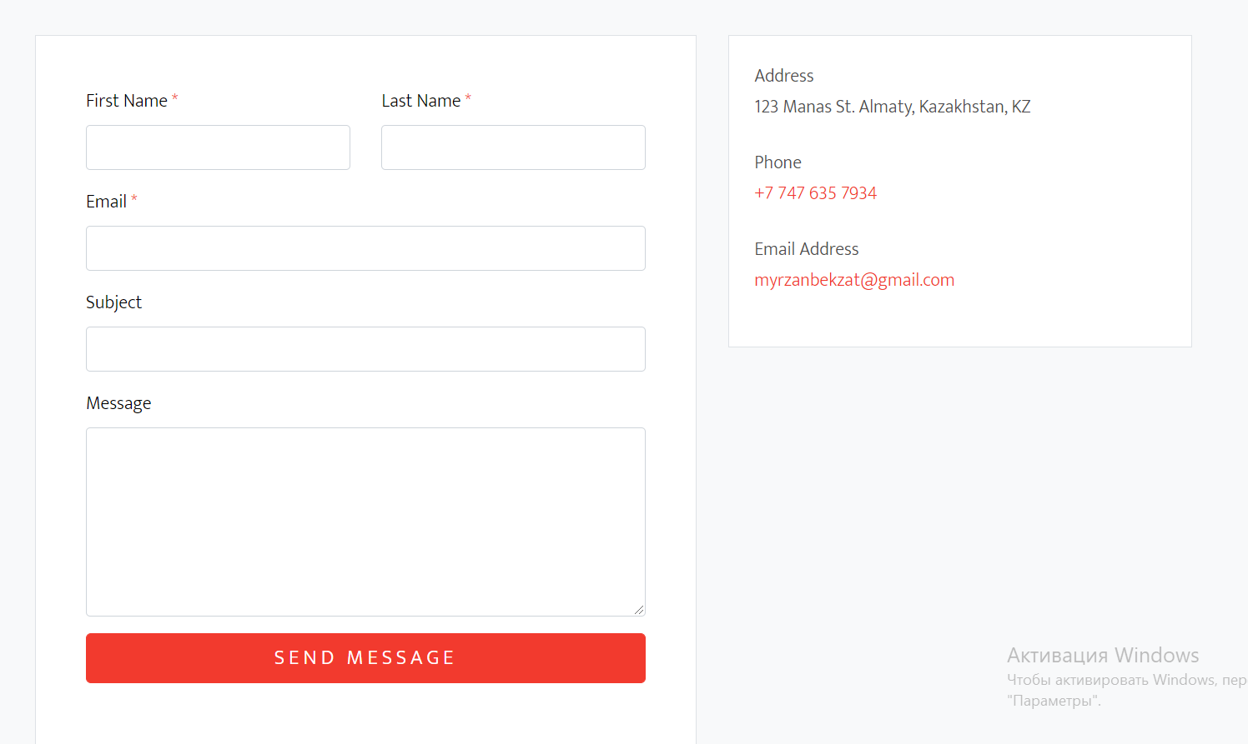

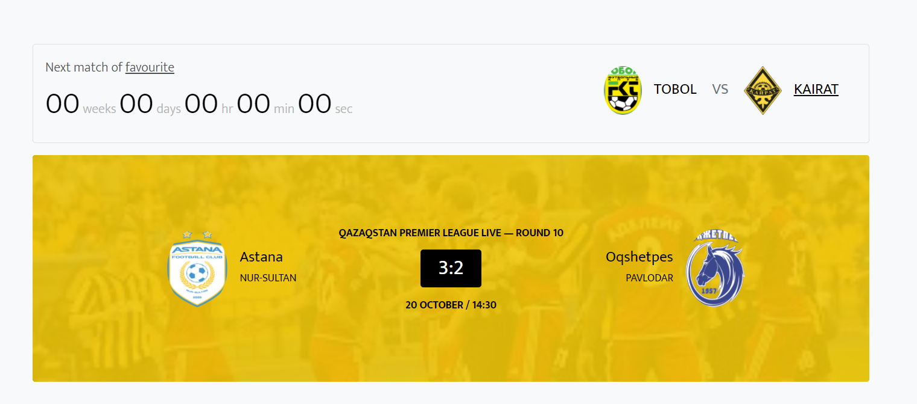



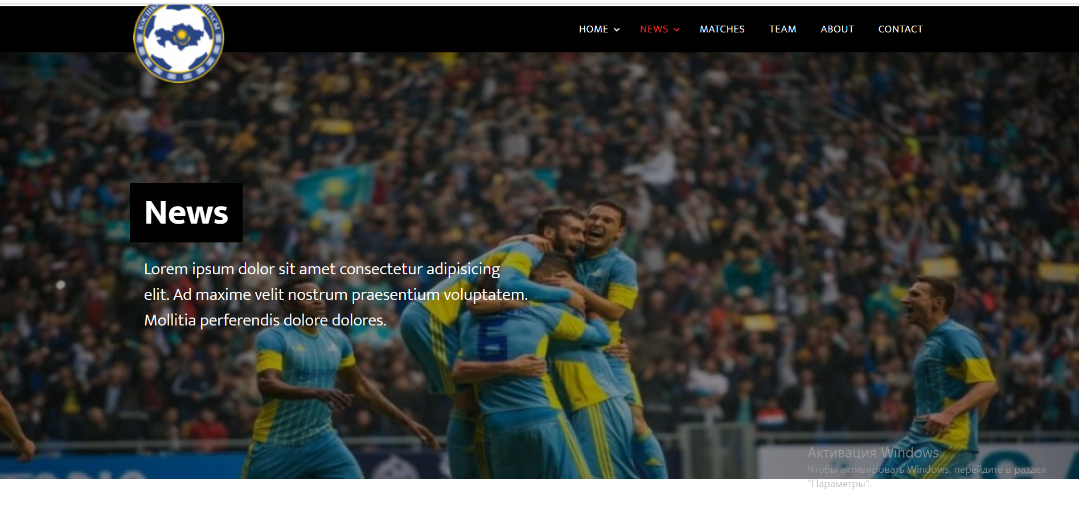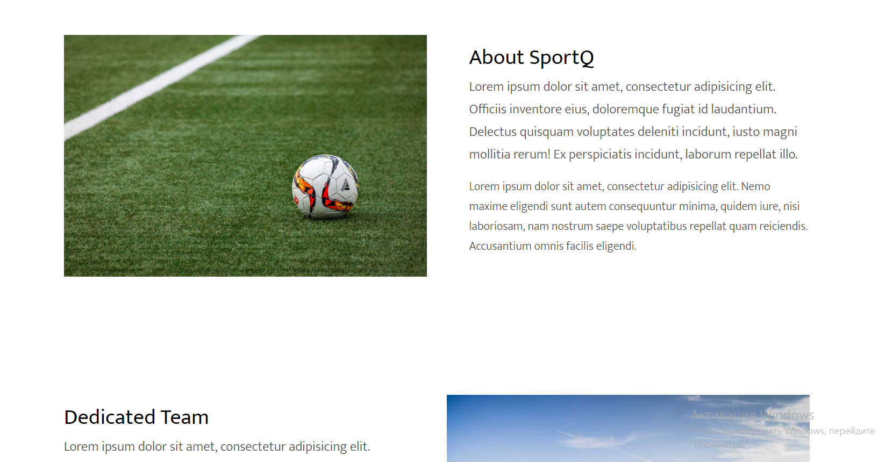

This project have Main page, Contacts page, Slideshows, News page, Teams page, About page  
and in this course work used html5, css, js, bootstrap elements

**Conclusion**

In conclusion, we create/build one fully working site/project with html5, css, js, bootstrap elements and practiced our skills gained during this 6 weeks  
PHP can actually do anything related to server-side scripting or more popularly known as the backend of a website. For example, PHP can receive data from forms, generate dynamic page content, can work with databases, create sessions, send and receive cookies, send emails etc. There are also many hash functions available in PHP to encrypt user’s data that makes PHP secure and reliable to be used as a server-side scripting language. So these are some of the abilities of PHP that makes it suitable to be used as server-side scripting language.

**References**

1.<https://www.tutorialspoint.com/php/php_introduction.htm>

2. <https://www.w3schools.com/php/DEFAULT.asp>

3. <https://www.tutorialrepublic.com/php-tutorial/>

4. <https://www.php.net/manual/ru/tutorial.php>

5. <https://www.phptpoint.com/php-tutorial/>